AWS Business Essentials:

Ability to grow (elasticity, scalability)

"Cloud Computing," by definition, refers to the on-demand delivery of IT resources and applications via the Internet with pay-as-you-go pricing.

Resource pulling

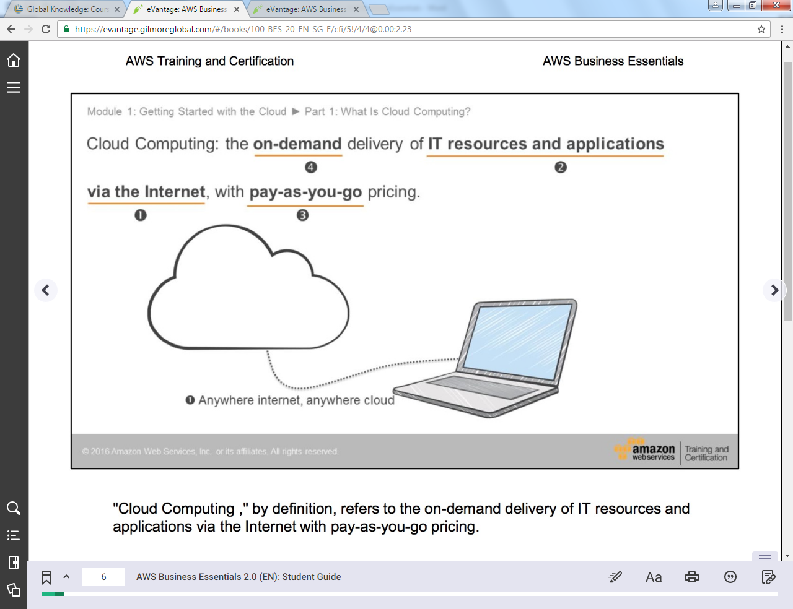

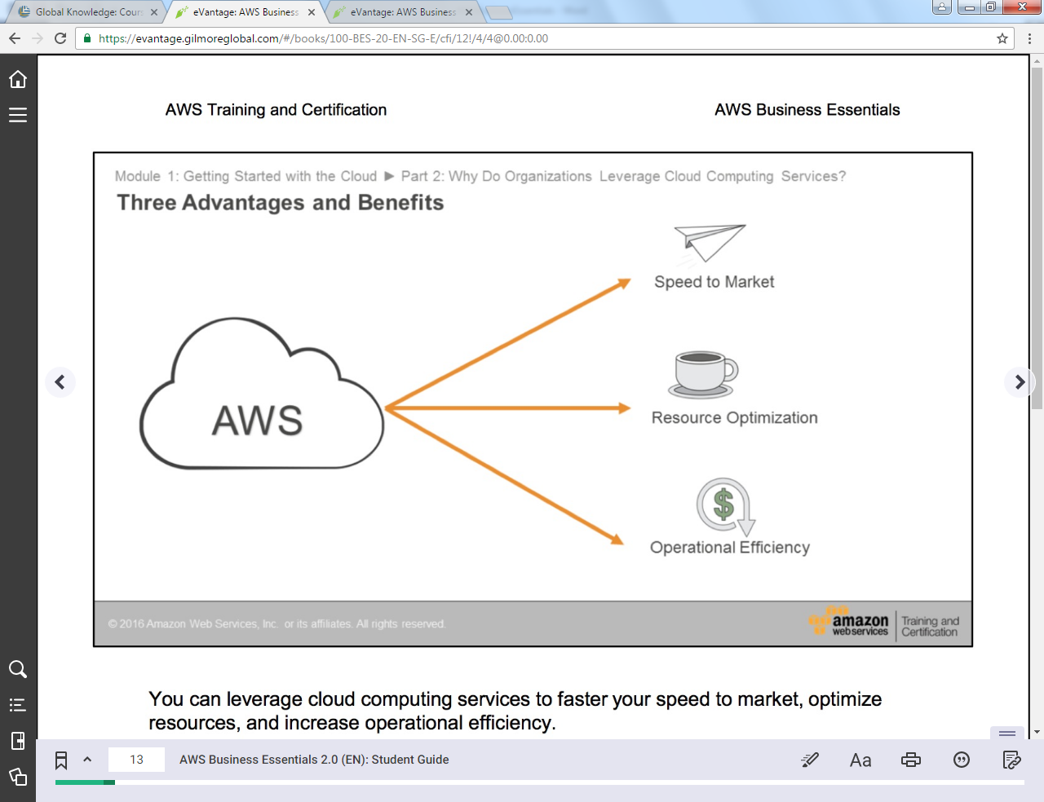

\*Resource optimization: Using what you need and pay for it, not wasting any resource.

Route53: Its amazon DNS

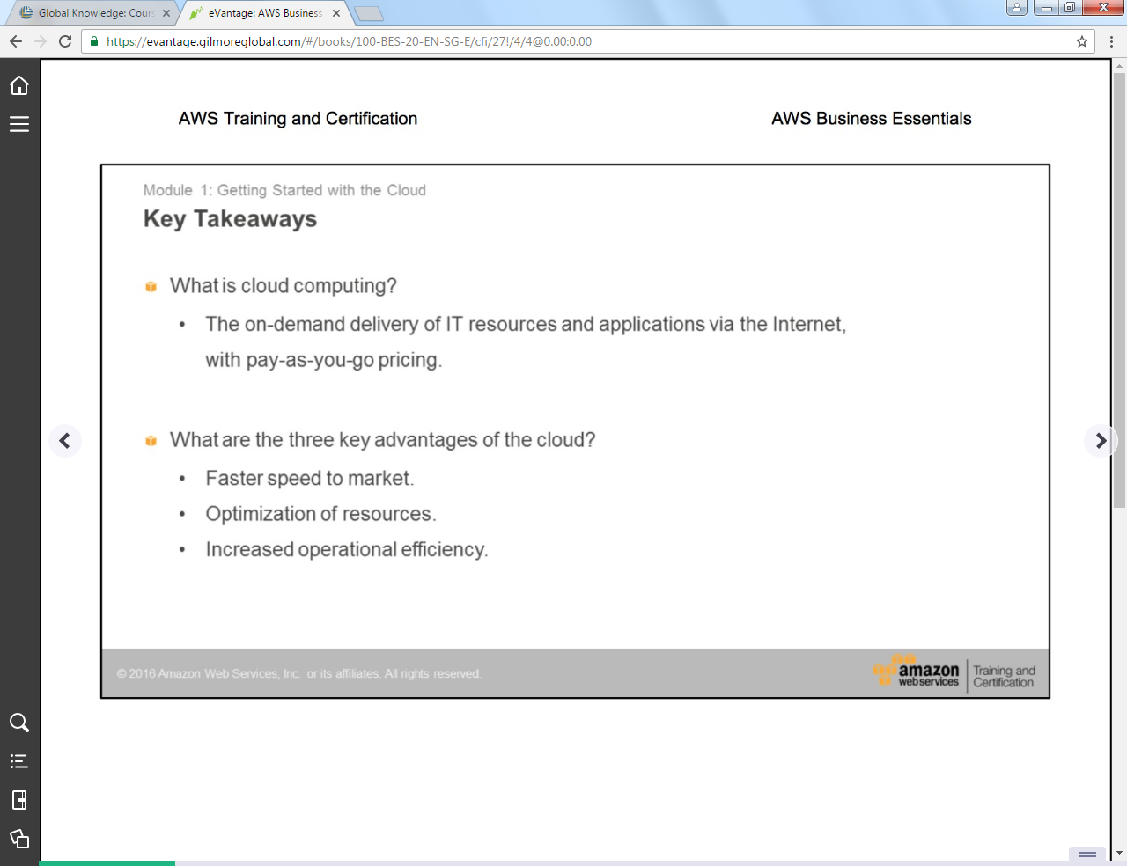

AMI: Amazon machine image, all Ec2 instance starts on this. It is cloneable.

If Ec2 instance needs to be patched it can be simply replaced instead of patching through AMI.

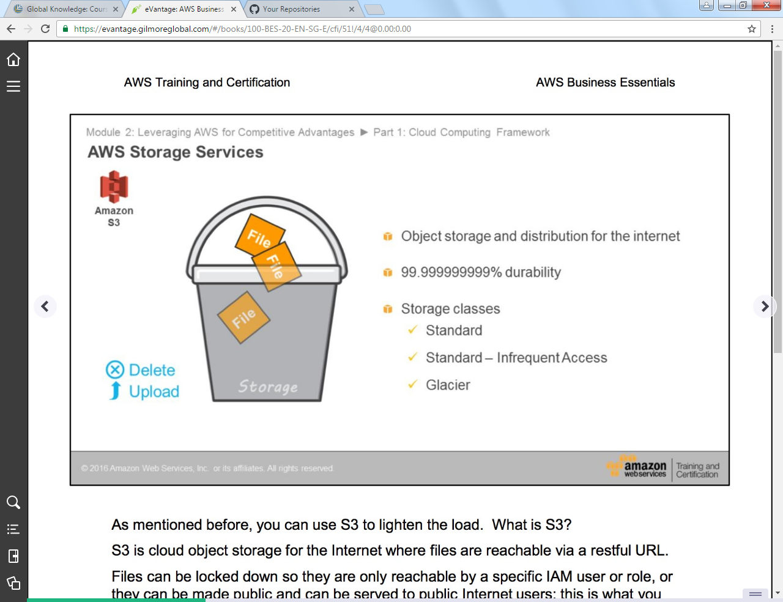

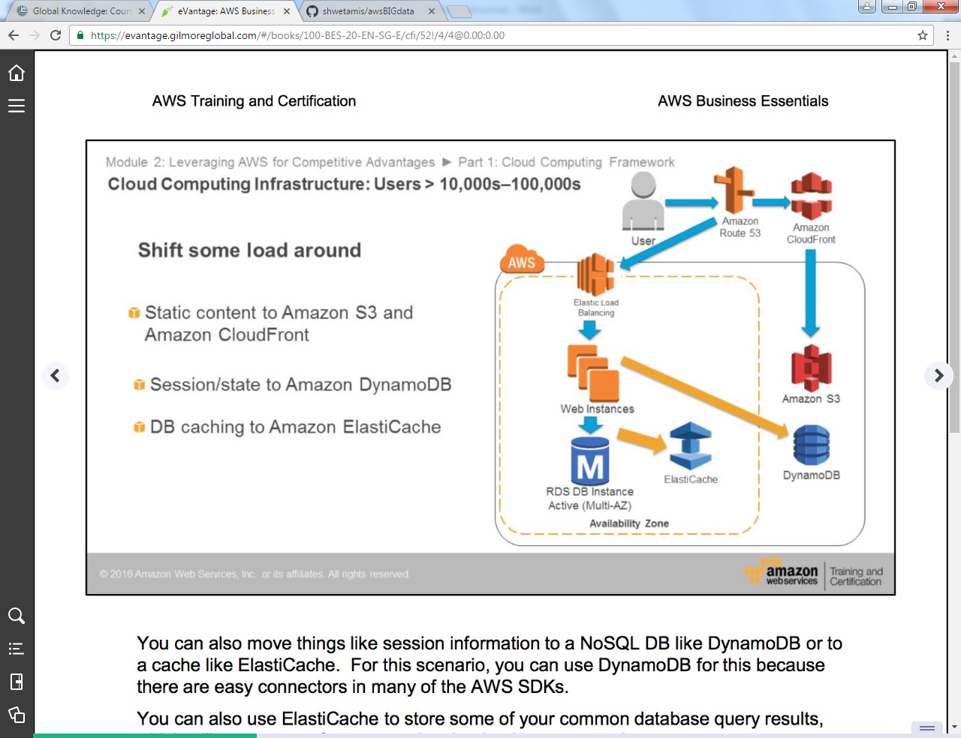

Pattern

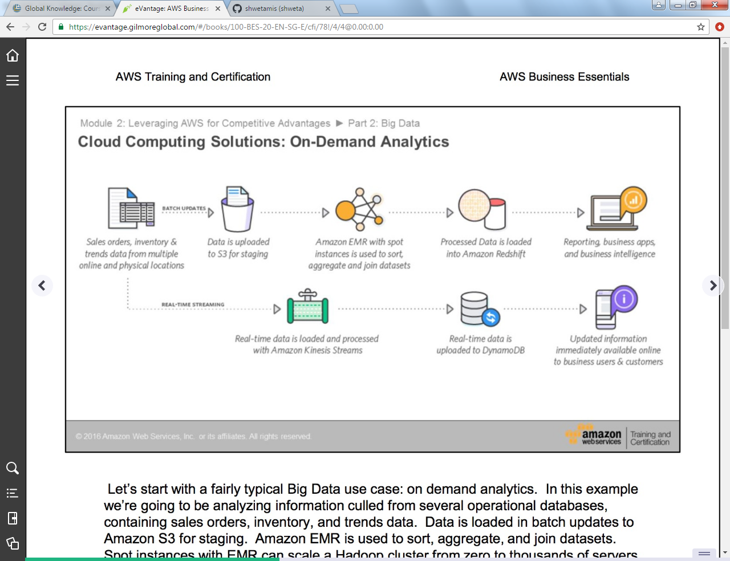

Kinesis will have raw and more real time data whereas DynamoDb will have more of operational/filtered data that will be used for business analysis.

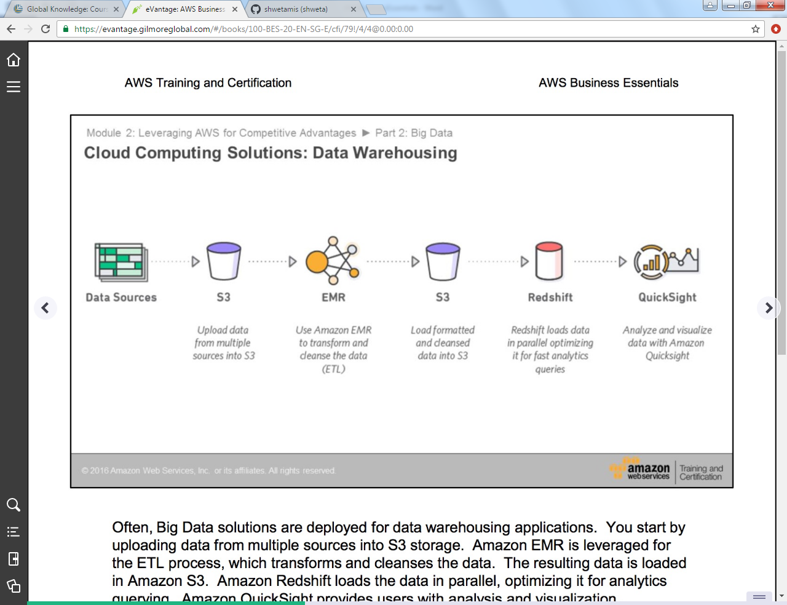

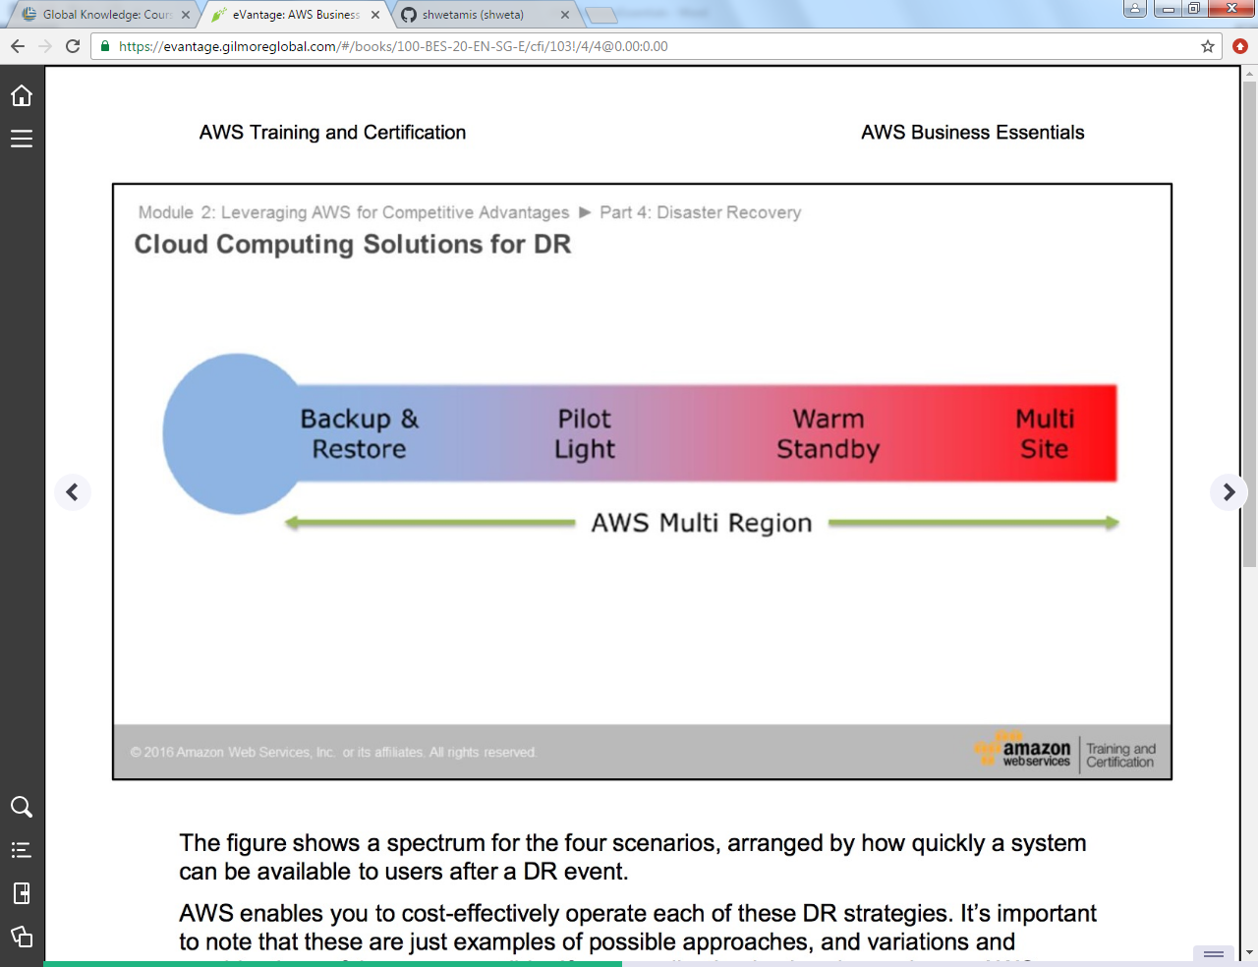

Backing everything on cloud and retrieve everything on failure on premises.

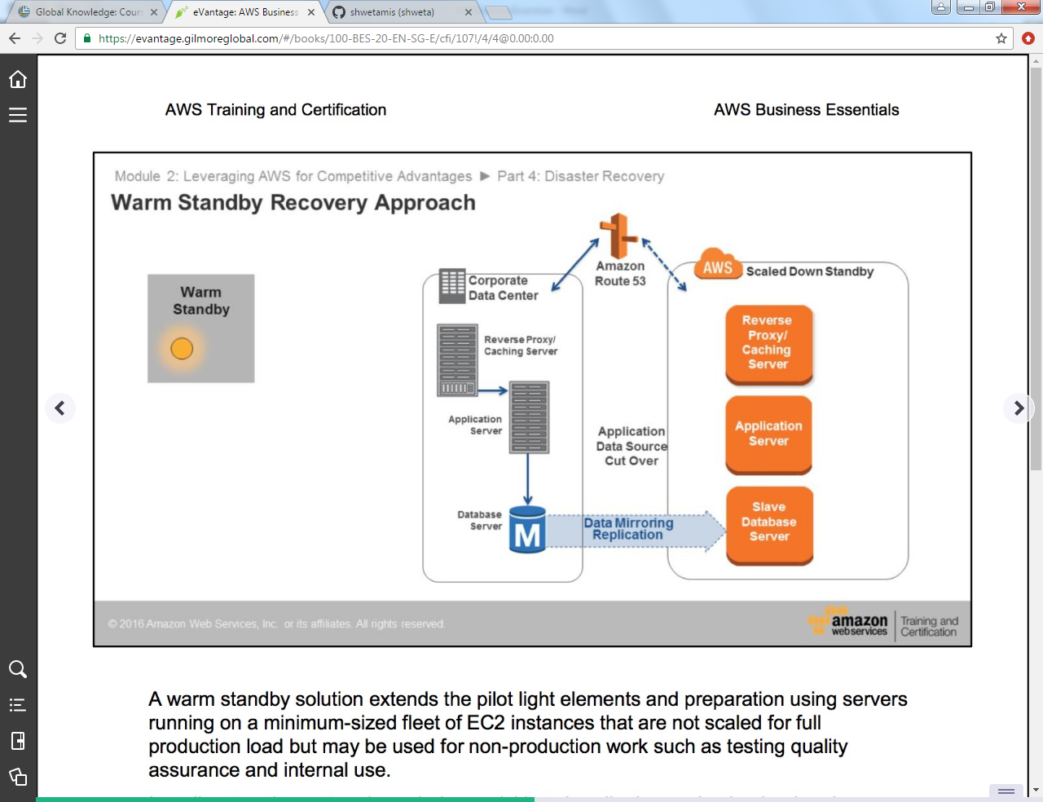

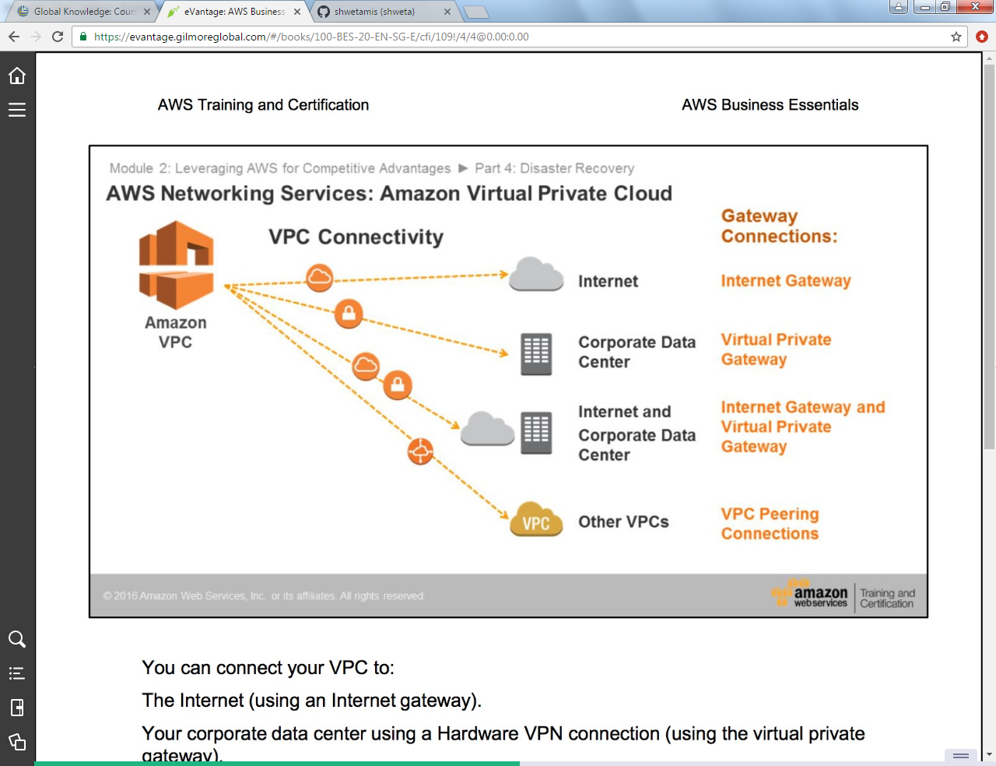

VPC: private isolated connection on aws

Direct connect: gives connection between private connect and aws region.

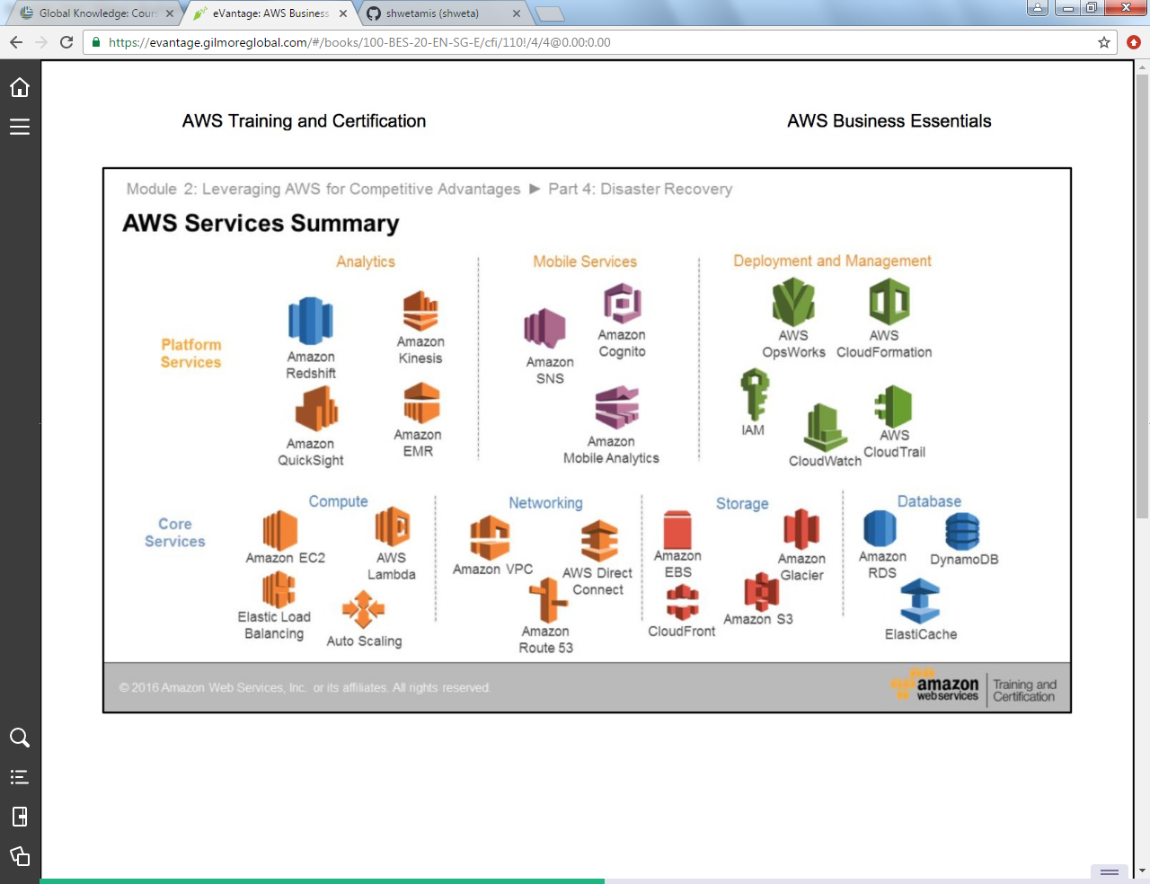

With S3: you pay for storage and number of request made.

With EBS you pay for amount to storage used.

